# About

DOCTOR ONLINE provides medical consultations for the patients with connecting well-experienced and professional doctors online around the world. Doctor Online care’s about you and follow your treatment with the international doctors.

# Departments

1. Internal
2. General Surgery
3. Neurosurgery and Spin Surgery
4. Orthopedics and Joint Replacement
5. Gynecology

# Services

We have wide expertise in connecting you with the specialist’s doctors around the world and general order medical supplies providers in the world on international standards. Our team is highly educated and has extensive experience of providing health and medical services. Moreover, we have a very good reputation at national and international level we are focusing on the client satisfaction because we believe in quality and standards.

# FAQs

Already available in website.

# Departments

1. **Internal**
2. **Neurosurgery and Spin Surgery**
3. **Orthopedics and Joint Replacement**
4. **Gynecology**

# Specialists

1. 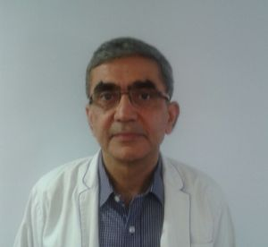Among the finest General Physician Doctors in the India, Dr. Arun Dewan (Max Smart Super Specialty Hospital) in Saket, Delhi is known for offering excellent patient care. The doctor holds an experience of 8 years and has extensive knowledge in the respective field of medicine. The doctor is an esteemed member of Indian Society of Critical Care Medicine (ISCCM), ISPEN, IRA and this only adds to the credibility of the doctor.
2. 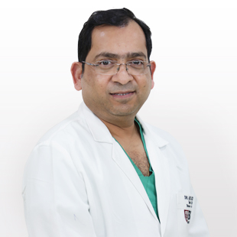Dr. Anil Kumar Kansal, one of the most accomplished Neurosurgeons in India, is the Director- Neurosurgery & Head -Neuro Spine of BLK Centre for Neurosciences. Dr. Kansal was earlier associated with Fortis Hospital, Shalimar Bagh. Dr. Kansal's academic credentials include MBBS, MS (General Surgery) and MCh. (Neurosurgery), from the prestigious King George's Medical College, Lucknow.
3. 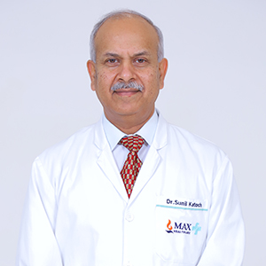Dr. Sunil Katoch has done postgraduate diploma, Registraship in Orthopedics from Medical College Rohtak & Fellowship in Spine Surgery form Switzerland and Germany. He has also trained in advanced operative skills in spine along with Prof. J.Y. Chung from South Korea. He has more than 25 years of experience in management of spinal problems. Prior to joining Max Healthcare, he was associated with Indian Spinal Injuries Centre, Vasant Kunj for 14 years & currently Senior Consultant- Spine Surgeon at Max Smart Super Specialty Hospital, Saket.
4. 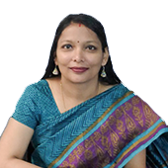Dr. Gunjan Goyal is your Gurgaon Obstetrician-Gynecologist & infertility specialist with over 10 years’ experience in quality obstetrics and gynecology. A graduate in medicine from the prestigious Thanjavur medical College, Tamilnadu, she completed her specialist training as Obstetrician & Gynecologist from the Sardar Patel University, Gujarat.
5. 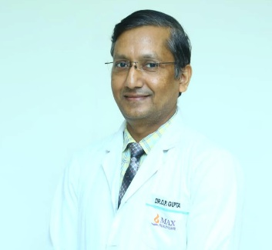Dr. O P Gupta is a renowned Orthopaedic Surgeon and Head of the Department of Spine Surgery, Max Smart Super Speciality Hospital, Saket, New Delhi. I am totally devoted and my interest is Spine Surgery. Doing more than 3000 Orthopedic and Spine surgeries in India and abroad, I feel that with what trust patients handover me their cases I successfully delivers them back with my hard work and knowledge, this can be clearly seen through the Smile on their and family faces. I have had extensive training in all aspect of spinal surgery.